# Design Report

## MDS 6117 Blockchain

## Blockchain-based Battery Traceability System

**Group 1: Digital Transformation Team**

**CHEN Honghao,  119010014**

**LI Jiaqi,  220041009**

**LI Jingyu,  118010141**

**ZHANG Mingzhe,  118020526**

Contents

Executive Summary 1

1 Project Introduction 1

1.1 Sponsor Background 2

1.2 Requirements Identification 2

1.3 Project Objective 3

1.4 System Overview 4

2 Project Description 5

2.1 Use case analysis 5

2.1.1 Industry Description 5

2.1.2 Industry Pain Points and Challenges 5

2.1.3 Blockchain Assessment Framework 6

2.1.4 Advantages and Disadvantages 9

2.1.5 Use case diagram 9

2.2 Data Models 11

2.2.1 Entities 11

2.2.2 Entity-Relationship Diagram 13

2.3 Dataflow diagram 15

2.4 Sequence diagram 15

3 Concluding Remarks 16

References 17

Appendix 18

## Executive Summary

## The battery industry is currently undergoing fierce competition enduring the bottleneck of battery supplies. The traceability and safety of battery supply have been industrial pain points for an extended period. Our project provides the sponsor with a blockchain-based traceability system to improve the supply chain visibility and responsiveness. The traceability system is based on a novel technology, blockchain, which drives decentralization and real-time data exchange among supply chain partners. Our blockchain solution is a good fit to solve the supply chain traceability problem based on the Blockchain Assessment Framework. Therefore, we develop the overall framework of the blockchain database system as the initial point of further project development.

## Project Introduction

* 1. Sponsor Background

The sponsor of the project is an electronic tool company, with a focus on group

purchase of battery-related raw materials and electronic instrument selling business. The battery supply chain of the company is demonstrated in **Exhibit 1**.

**Exhibit 1. Battery & Electronic Tool Industry Supply Chain**

* 1. Requirements Identification

Battery is expensive, complex, and requires specific manufacturing and logistics conditions. Meanwhile, there exists a high risk of the explosion of batteries, which contributes to huge cost and safety concerns to our sponsor and all supply chain partners. The current situation is, due to the potential risk of explosion, the company needs an efficient and reliable battery traceability system to monitor the production and logistics status of batteries throughout the supply chain.

The need of traceability is composed of three dimensions:

* Be able to monitor and control the battery production and selling process.
* Ensure the records are reliable and easily retrieved, and clear the allocation of responsibility.
* Share real-time logistics status to entities, enhancing supply chain visibility and trust.
  1. Project Objective

Based on the needs analysis, our Digital Transformation Team proposes a blockchain-based information system to trace the movement of batteries along the supply chain to achieve the main objective of **making the movement and conditions of batteries traceable and strengthening battery supply chain visibility**. Through the blockchain system, we expect to complete two value-added features that traditional databases cannot provide *at the operational level*:

* Enable the reliability and extractability of battery data.
* Enable real-time monitor of battery status.

*At the strategical level*:

* Build trust and partnership among supply chain partners.
* Improve visibility and responsiveness and the overall supply chain performance.

The logic of applying blockchain system is,

* First, blockchain is a decentralized system, and it is a reliable medium to share battery information to supply chain entities and boost trust.
* Also, blockchain has the properties of efficient and automated transaction processing, plus tamper-proofing data storage, which benefits the company by cutting labor costs and operations lead time.
* Moreover, blockchain is ultimately an information system to improve supply chain transparency/visibility. The visibility of battery status empowers the company to monitor and control the production and logistics process and equips the company with information needed to execute the battery recycling process.
  1. System Overview

As shown in **Exhibit 2**, we build a blockchain-based system as a decentralized database shared among supply chain partners.

Generally speaking, the ellipse represents the blockchain platform where different roles can perform the corresponding function to influence the chain (e.g., create product information, query product). The five nodes (participants) are listed below, namely the raw material supplier, battery supplier, electric tool manufacturer, logistics provider and channel partners. Each node represents a role during the battery processing procedure and possesses a distributed database containing all product information (assets). The databases are identical among different nodes. Individual nodes have interactions (transactions) with the blockchain platform interface through the smart contract mechanism. In addition, end customers can query product information through the platform. The detail of the use cases, data organization, data flow, and product transfer procedure will be shown in the following part.

**Exhibit 2 Blockchain System Overview**

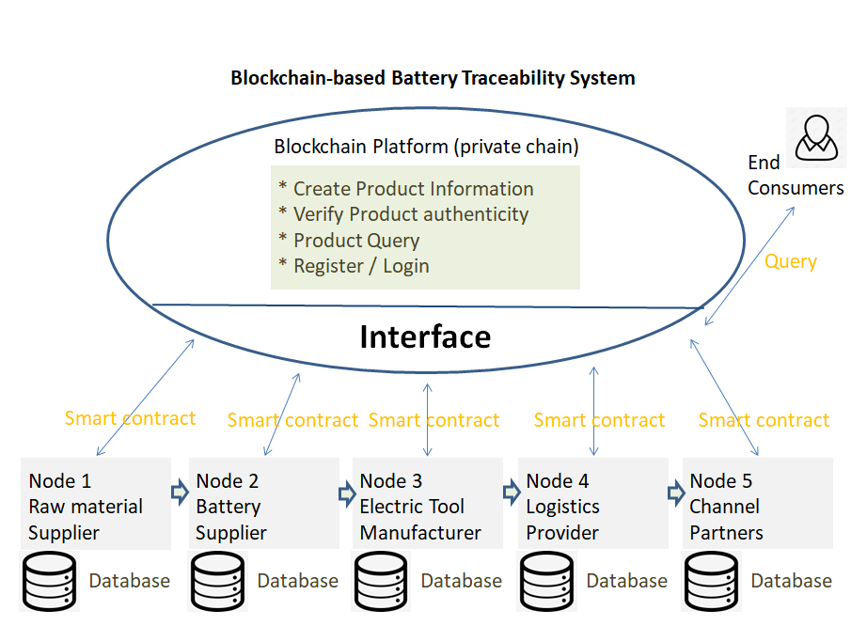

## Project description

* 1. Use case analysis
     1. Industry Description

Electric power tools refer to tools that drive the working head through a transmission device. It has many different types, for example, electric drills, electric saws, electric wrenches, electric hammers, heat guns, etc. At present, the electric power tool industry concentration is low, and the market competition is fierce. To fight for market share, companies are committed to improving their capabilities in research, development, production, quality, marketing, business management, and other aspects. High product safety can contribute a lot to company's R&D efficiency, product quality, and corporate reputation.

Electric power tools can be divided into AC power tools and lithium battery power tools in terms of power supply. The convenience of lithium battery power supply is far superior to that of AC power supply, so it has become the future development trend. However, the electrode materials and electrolytes of lithium batteries are flammable. A lithium battery of poor quality can easily cause combustion and explosion when being affected by heat. The anode and cathode materials, electrolyte and its additives, the structure of the battery, and the manufacturing process had an important effect on the safety of the Li-ion battery. The environment in which the battery is transported and stored also affects the safety of the battery. Therefore, to ensure the safety of lithium batteries on the electric power tools, the companies must know and supervise the production process in their battery suppliers adequately. Besides, they also stipulate safety precautions for storage, transportation, and charging of electric power tools, such as temperature range, charging duration, etc.

* + 1. Industry Pain Points and Challenges

Although the electric power tool companies understand the importance of safety of lithium battery on their products, they still have many obstacles to supervise the production process of the batteries. First of all, for lithium battery manufacturers, the core technology of lithium battery manufacturing is a corporate secret. Therefore, it is impossible to allow the demand side to send people to supervise production. They will only provide the demander with a third-party quality inspection report to prove that their products meet the requirements. This is also the mode that is widely adopted at present. However, there exists some pain points and challenges in this pattern:

* Lithium battery manufacturers may collude with third-party quality inspection agencies to issue false quality inspection reports. This may allow products that would otherwise not meet the standards to enter the market.
* Even if the quality inspection report itself is true, the performance it can detect cannot fully reflect the safety of lithium batteries. The manufacturer may pass the quality inspection through various means, but the product does not actually meet the standard (such as the melamine milk incident in the food field).
* For the manufacturers themselves, it is difficult to fully guarantee the quality of the raw materials and parts used in the production of batteries.
* The quality inspection of lithium batteries requires the manufacturer to pay a fee.
* The acquisition of the quality inspection report requires many steps, including the manufacturer's application, the manufacturer's mailing of samples, the quality inspection agency's quality inspection, and the mailing of the report after the inspection is completed, which often takes several weeks.
* As for the transportation, storage, and charging process of electric power tools, although electric power tool companies realize their importance to battery safety, it is quite challenging to control these related processes. The reason is that logistic providers conduct transportation, and channel partners run storage. Full supervision is not realistic. The current mode is that the companies enclose detailed product specifications with the products. However, whether logistic providers and channel partners operate according to the product specification is not guaranteed.
  + 1. Blockchain Assessment Framework

The below assessment table shows the feasibility of Blockchain-based Battery Traceability System in the battery supply chain industry.

**Exhibit 3 Blockchain Assessment Framework**

|  |  |  |  |
| --- | --- | --- | --- |
| INDUSTRY FOR BLOCKCHAIN APPLICATION: Battery Traceability System | | | |
| Number | Factors | Assessment Framework | Does Blockchain Fit? Why? |
| 1 | Intermediary | l  High fees for intermediary?  l  Latency due to processing through intermediary?  l  Does the intermediary exist due to lack of a trust? | Yes.  Traditional quality supervision pattern highly relies on third-party inspection agencies due to lack of trust. Obtaining the report usually costs several weeks.  Every procedure in the supply chain can plug into the blockchain and record production and transportation details, which is a powerful supplement to inspection reports. After being mature, electric power tool companies can even purchase high-quality batteries without third-party's quality inspection. |
| 2 | Transparency | l  Are multiple participants involved?  l  Does increase in transparency into the transaction help the participants? | Yes.  Electric power tool companies, lithium battery manufacturers, raw material suppliers, logistic providers and channel partners are all involved.  Higher transparency can help each downstream customer control their product quality by controlling the quality of product parts. |
| 3 | Golden Source | l  Are multiple participants storing the same information in multiple locations?  l  Is data consistency an issue? | Yes.  Common information like product id, location, timestamp needs to be stored by all participants in this supply chain. Blockchain can guarantee data consistency in all participants' servers. Product information has to be gathered from multiple sources for tracing. |
| 4 | Manual Processing | l  Does the process involved manual operations?  l  Is the cost of reconciliation high? | Yes.  Original lithium battery products and electric power tool transportation need to record many paper-intensive data like machine parameters, temperatures, which requires lots of manpower. |
| 5 | Trust | l  Is there trust among participants?  l  Do multiple participants have the right to modify transactions?  l  Is there a risk of fraudulent transactions? | Yes.  Lack of trust exists between battery suppliers and downstream electric power tool companies, as well as logistic providers, and channel partners. The risk of inferior batteries does exist because suppliers can get a passed quality inspection report for an inferior battery through any means. The risk of irregular storage and transportation for electric power tools also exists. Since information may be unknown to each other, there is a lack of trust and the possibility of fraudulent activities. |
| 6 | Documentation | l  Is the documentation paper-based?  l  Is there a large number of documents/reports required to be generated (e.g. for regulatory purposed)? | Yes.  The product information, validations report, quality inspection report, logistic address, bills, the recordings of the process of quality inspection, etc. are all paper-based and require documentation. |
| 7 | Time Sensitivity | l  Will the transactions benefit from being real-time or synchronous? | Yes.  Every participant will benefit from real-time data visibility. It will help in providing enhanced customer experience and responsibility confirmation process, and reduce the exposure risk of quality problems if the recording process is in real-time. |

* + 1. Advantages and Disadvantages of Blockchain Application in The Battery Traceability System

Based on the blockchain assessment framework, the advantages and disadvantages of the battery traceability system can be summarized.

The battery traceability system based on blockchain has many advantages comparing with traditional quality inspection. First, the blockchain has the tamper-proof feature. When the production equipment is connected to the blockchain, the system can truly record all the processes of battery production, including raw material composition, production environment parameters, whether key operations to prevent explosions have been carried out, etc.This can be a powerful supplement to inspection report. After being mature, electric power tool companies can even purchase high-quality batteries without third-party’s quality inspection. Blockchain can also record the process of battery transportation and storage. If iregular operation occurs, the electric power tool companies can remind the logistic providers and parterner channels to make them correct the errors in operation. Second, the records in the blockchain are fully traceable. Once an accident occurs during the use of the product, the production, transporation and storage data can be quickly analyzed to investigate the cause and prosecute those responsible. Third, the generation of the records are nearly in real time, which saves a lot of time.

However, the disadvantages of the battery traceability system cannot be ignored. First, in this system, every participant’s production process is visible, which may cause leaking of the secrets about the product design. Second, the data in the blockchain is highly duplicated. Every node in the system stores all the production data. As the quantity of the products increase, the nodes will store more and more data, which will be a burden for the storage hardware of the nodes. Third, the set-up of this traceability system may be difficult and expensive. Since blockchain application has not been popularized in supply chain, lots of things need to be done in the initial phase of the blockchain network construction of battery supply chain.

* + 1. Use case diagram

The following figure shows the use case diagram of our blockchain-based battery traceability system.

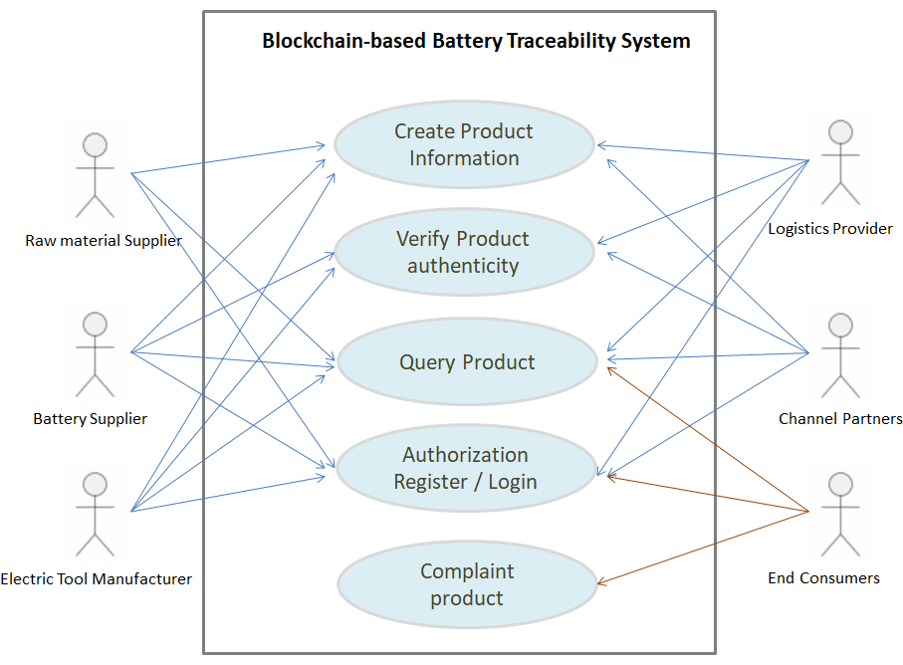

There are mainly five operations:

1. Create product information: The participants in the supply chain can create information regarding the product. For example, raw material supplier can create copper information and upload a unique id and its purity; logistic provider can create logistic information about the product location, timestamp; Channel partners can upload transaction information. Since the data in a blockchain cannot be tampered, modifying product information is equivalent with creating new information. End customers cannot upload product information since they don't produce.
2. Verify product authenticity: Every participant in the supply chain can verify whether the information from upstream is authentic so that it can proceed in the following steps. For example, electric tool manufacturer can verify the information uploaded by raw material supplier and battery supplier, if there are fake data, the product cannot transfer downstream. Relevant bureau in charge / inspection agency will deal with the case. The most upper stream material supplier and most lower stream end customer cannot verify the authenticity.
3. Query product: Every participant can perform query on a product. Participants can use the information to arrange business strategy or identify responsibility. Customers mainly use this use case to trace product information.
4. Authorization: register / login: This is the common function to get access on the blockchain system. Every user has the account and password to register / login.
5. Complaint product: This is the special function for end customers. If they find quality problems of a product, they can complaint through the system and association of consumers and relevant company will try to solve the problem.
   1. Data Models
      1. Entities

In this Blockchain-based Battery Traceability System, the entities can be divided into four categories, i.e., participant, battery raw material, battery, electric tool.

*Participant*

Participants are members of the business network. Each participant is associated with a specific role: material supplier, battery manufacturer, electric tool manufacturer, logistic provider, and channel partners. Different roles lead to different attributes stored in the database and different actions they can perform. Specialization is used in designing participant entities. The resulting design is shown in the following diagram.

**Exhibit 4 Composition of Participant Entity**

*Battery Raw Material*

Battery raw materials are the materials used by battery manufacturers to produce batteries. There are several types of raw materials, including lithium, steel, copper, plastic, etc. Similar to participant entity, specialization is used in designing raw material entity, as shown below.

**Exhibit 5 Composition of Battery Raw Material Entity**

*Battery*

Batteries are produced by battery manufacturers from raw materials and are then used by electric tool manufacturers to produce electric tools. The producing process of batteries s kept track of by our system. The entity representation of battery will be shown in the complete Entity-Relationship Diagram later.

*Electric Tool*

Electric tools are produced by electric tool manufacturers using batteries from battery manufacturers. The entity representation of electric tool will be shown in the complete Entity-Relationship Diagram later.

* + 1. Entity-Relationship Diagram

Linking the entities above with relations, the complete Entity-Relationship Diagram can be obtained as follow. Note that to simplify and increase readability of the diagram, only two of the raw materials presents in the figure. More raw materials can be added to the system following a similar manner. Detailed demonstrations of the entity-relationship diagram are shown in **Exhibit 6.** The relations linking different entities represent participants’ actions (transactions) on assets (including battery raw materials, batteries, and electric tools). The relations can be categorized into three types:

* Supplying Raw Materials

New raw materials are introduced in the system by suppliers and are ready to be used to produce batteries.

* Manufacturing Battery / Electric Tool

Manufacturers consume raw materials to produce batteries or consume batteries to produce electric tools.

* Transporting Electric Tool

Electric tools are transported through the supply chain and finally delivered to consumers. Manufacturers, logistic providers, and channel partners participate in the transportation process.

**Exhibit 6 Entity-Relationship Diagram**



* 1. Dataflow diagram

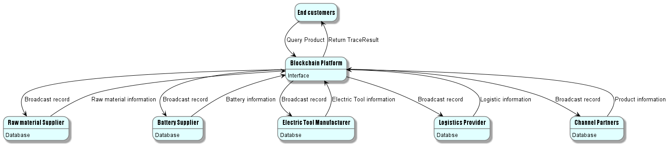

The data flow diagram (DFD) shows the data input flow and output flow status of several participants and the blockchain system. The blockchain battery traceability system serves as the interface among different roles’ interaction and data transition. Supplier is the upstream role that provides the raw material, and it uploads material information to the chain, and the chain will record the information and send it to every node through gossip mechanism. Similarly, the manufacturer will upload assembled product information, the logistics provider will update location information, and the distributor will upload product information on the shelf, while the blockchain system will perform corresponding operations to record the data on the chain. The details of the information are discussed in the E-R diagram part. Especially, customers cannot upload information but query product, then the chain will return relevant information for tracing and fraud prevention.

* 1. Sequence diagram

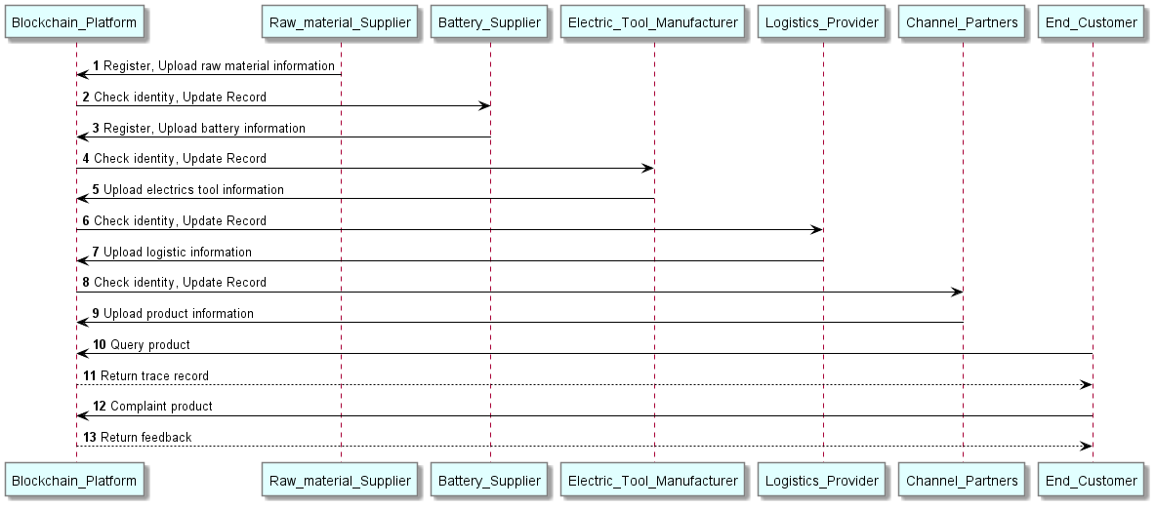

The above figure shows the sequence diagram of the system. Upstream participant raw material supplier registers to the system, and try to upload material information. The platform will verify the identity and broadcast the information to all other nodes using gossip mechanism. Once the next participant in the supply chain, the battery supplier receives the information, it can register and check the authenticity of the material, and then create new information in its level. By passing information to next and making use of previous one's, we transfer the product to the channel partners step by step. Different data from each part of the supply chain are gathered through this process (product id, location, material content, cost, timestamp...). Finally, end customers can trace product with identification like product id or product QR code. If customers find quality problem, they can complaint about it.

## Concluding Remarks

We have shown the good fit of the blockchain system with supply chain traceability application via use case analysis. Combining the theoretical analysis with the background of our sponsor, we further designed the overall framework of this Blockchain-based Battery Traceability System. The system structure is clearly modeled through the use case diagram, entity-relationship diagram, data flow diagram, etc. We will follow the designed framework and implement this traceability system on Hyperledger Fabric in the future.

## References

Backhaus R. (2021). Battery Raw Materials - Where from and Where to?. *ATZ worldwide*, *123*(9), 8–13. <https://doi.org/10.1007/s38311-021-0715-5>

Team Cellerite. (2020). *Battery Parameters.* <https://www.cellerite.com/post/battery-parameters>

## Appendix

Project plan

